Community of Practice Models
There are several ways you can approach your community of practice to best fit your goals and anticipated faculty bandwidth. Here we recommend three models that were used throughout the Student Experience Project, all representing different levels of faculty commitment. Each model uses field-tested SEP resources from the Classroom Practices Library and the Ascend platform. These models can be adapted to fit your needs. On the following pages we provide a suggested timeline for each model.
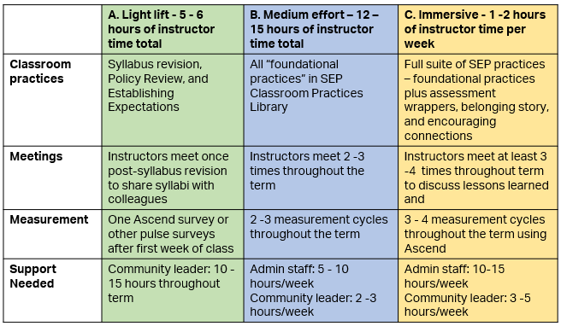

Model C: Immersive
Plan to hold an orientation meeting approximately two weeks before the term begins. We recommend providing a timeline like this one to instructors prior to the orientation meeting.
Before the orientation meeting, instructors should:
- Complete syllabus revision module
- Revise their syllabi
- Review practices for the first week:
  - Establishing Expectations
  - Policy Review
- Set up their Ascend accounts and survey cycles
At the orientation meeting:
- Help instructors get to know one another and build community
- Discuss syllabus revision process and have faculty get feedback from one another
- Remind everyone of practices for first week
1 – 2 weeks after the start of the term, meet with instructors to:
- Debrief on student experience data from the first week(s) of class
- Discuss practices from the first week – what went well, where might there have been challenges?
- Introduce assessment practices that instructors should use leading up to first assessment:
  - Wise Feedback Statements
  - Attuned Assessment wrappers
- Continue community-building exercises
- Prepare for next Ascend cycle
Just after midterms, meet with instructors to:
- Debrief student experience data from latest cycle(s)
- Discuss assessment practices – what did they find valuable? Where might there have been challenges? What might they want to repeat or change prior to final exams?
3 -4 weeks before the term ends, meet with instructors to:
- Debrief student experience data from latest cycle and discuss trajectories across the term
- Reinforce that they can and should continue utilizing practices from earlier in the term – encouraging connections, belonging messages, and ensuring classroom identity safety are all important as students approach final exams.
- Prepare for final Ascend survey cycle
- Consider holding a final meeting after exams for additional reflection
Model B: Medium Effort
Plan to hold an orientation meeting approximately two weeks before the term begins. We recommend providing a timeline like this one to instructors prior to the orientation meeting.
Before the orientation meeting, instructors should:
- Complete syllabus revision module
- Revise their syllabi
- Review practices for the first week:
Establishing Expectations
  - Policy Review
- Set up their Ascend accounts and survey cycles
At the orientation meeting:
- Help instructors get to know one another and build community
- Discuss syllabus revision process and have faculty get feedback from one another
- Remind everyone of practices for first week
- Encourage faculty to review the resource on establishing classroom identity safety and consider how they might create an identity-safe learning environment.
1 – 2 weeks after the start of the term, meet with instructors to:
- Debrief on student experience data for the first week(s) of class
- Discuss practices from the first week – what went well, where might there have been challenges?
- Introduce wise feedback statements
- Continue community-building exercises
3 -4 weeks before the term ends, meet with instructors to:
- Debrief student experience data for latest cycle(s)
- Discuss wise feedback statements – what did they find valuable about this approach? Where might there have been challenges? What might they want to repeat or change prior to final exams?
- Prepare for final Ascend survey cycle and provide a few reflection prompts for instructors to consider on their own at the end of the term

Model A: Light Lift
Plan to hold an orientation meeting approximately two weeks before the term begins. We recommend providing a timeline like this one to instructors prior to the orientation meeting.
Before the orientation meeting, instructors should:
- Complete syllabus revision module
- Revise their syllabi
- Review practices for the first week:
Establishing Expectations
  - Policy Review
At the orientation meeting:
- Help instructors get to know one another and build community
- Discuss syllabus revision process and have faculty get feedback from one another
- Remind everyone of practices for first week

If desired, 1 – 2 weeks after the start of the term, meet with instructors to:
- Discuss the first week of class and how their new syllabi were received
- Debrief any data they may have collected on students’ perceptions of and experience with the syllabus.
- Introduce instructors to other available SEP resources to deepen their practice:
  - Wise Feedback Framing Statements, an approach to delivering critical feedback in a way that engenders trust, increases academic engagement, and helps close academic outcome gaps;
  - Ensuring Classroom Identity Safety, approaches to creating classroom learning environments where students from diverse identities feel welcome, valued, respected, and as though they are recognized as having the potential to succeed
  - Ascend, a survey tool instructors can use to understand how students are experiencing their course
  - There are many other practices available in the SEP Practices Library.

SEP Timeline – for Instructors

Model C: Immersive
Before the term begins:
- Revise your syllabus
- Complete policy review
- Review recommendations for ensuring identity safety, identify 1 -2 practices that would work well in the context of your course.
- Review recommendations on supporting financially stressed students

Attend orientation meeting

During the first week of class:
- Utilize revised syllabus
- Convey a growth-mindset approach to course expectations
- Share belonging story
- Utilize practices to encourage connections in the classroom
- First student survey on course experiences

Just before the first major assessment:
- Review wise feedback implementation guide and develop your statement
- Share insights about common points of difficulty and opportunities for them to help in their preparation for the assessment

When returning feedback on first major assessment:
- Share wise feedback statement with students when handing back graded work
- Provide post-assessment reflection activity
- Second student survey on course experiences

2 weeks before the end of the term:
- Remind students of reflections on assessments from earlier in the term
- Third student survey on course experiences
- Continue sharing belonging and growth mindset messages

SEP Timeline – For Instructors

Model B: Medium Effort
Before the term begins:
- Revise your syllabus
- Complete policy review
- Review recommendations for ensuring identity safety, identify 1 -2 practices that would work well in the context of your course.

Attend orientation meeting

During the first week of class:
- Utilize revised syllabus
- Convey a growth-mindset approach to course expectations
- First student survey on course experiences

Just before the first major assessment:
- Review wise feedback implementation guide and develop your statement

When returning feedback on first major assessment:
- Share wise feedback statement with students when handing back graded work
- Second student survey on course experiences

2 weeks before the end of the term:
- Third student survey on course experiences
- Continue sharing belonging and growth mindset messages

SEP Timeline – For Instructors

Model A: Light Lift
Before the term begins:
- Revise your syllabus
- Complete policy review
Attend syllabus debrief meeting
During the first week of class:
- Utilize revised syllabus
- Convey a growth-mindset approach to course expectations

